*Z.H.C.E.T., Aligarh Muslim University – Aligarh*

**Advanced Computing Lab**

(COC **3960**)

**EXPERIMENT R3**

Submitted to: **Dr Ash Mohammad Abbas**

Submitted by: **Ravi Sahni**

Faculty No.: 17 COB **085**

Enrolment No.: GJ 7718

Serial No.: **24**

Class: B. Tech. (A3CO)

**Experiment R3:** Write a program to find the Convex Hull of a set of points.

**Sample Input:**

Below is a sample set containing 20 points:

***{16, 3}, {12, 17}, { 0, 6}, {-4, -6}, {16, 6}, {16, -7}, {16, -3}, {17, -4}, { 5, 19}, {19, -8}, { 3, 16}, {12, 13}, { 3, -4}, {17, 5}, {-3, 15}, {-3, -9}, { 0, 11}, {-9, -3}, {-4, -2}, {12, 10}***

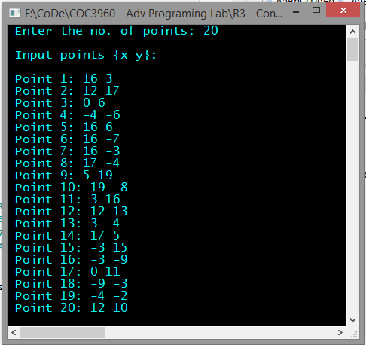

**Sample Output:**



